2. PIEEC LifeLong Learning Info Desk
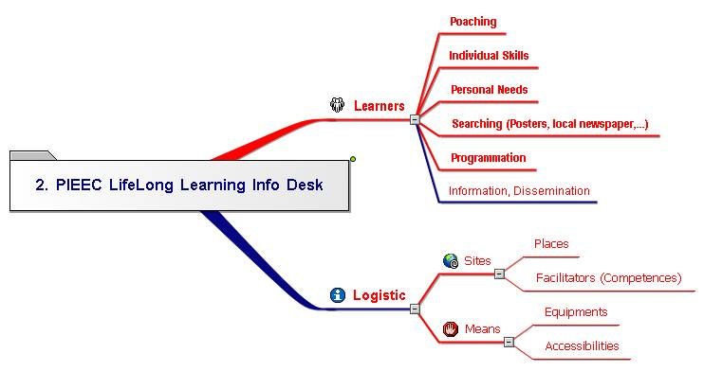
1. Learners 2
1.1. Poaching 2
1.2. Individual Skills 2
1.3. Personal Needs 2
1.4. Searching (Posters, local newspaper,...) 2
1.5. Programmation 2
1.6. Information, Dissemination 2
2. Logistic 2
2.1. Sites 2
2.1.1. Places 2
2.1.2. Facilitators (Competences) 2
2.2. Means 2
2.2.1. Equipments 2
2.2.2. Accessibilities 2

ACRE 2 Final Goals c:\documents and settings\administrateur\mes documents\euro-cides\pj acre 2\acre 2 final goals.ppt

Learners

Poaching

Individual Skills

Personal Needs

Searching (Posters, local newspaper,...)

Programmation

Information, Dissemination

Logistic

Sites

Places

Facilitators (Competences)

Means

Equipments

Accessibilities

