1. Project ACRE 2
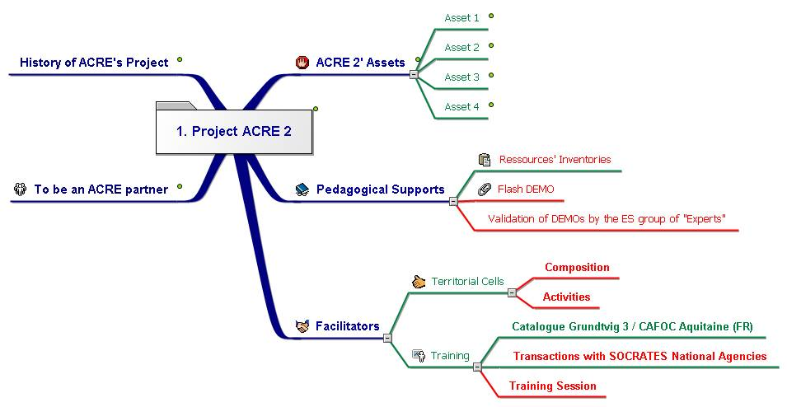
1. ACRE 2' Assets 2
1.1. Asset 1 2
1.2. Asset 2 2
1.3. Asset 3 2
1.4. Asset 4 2
2. Pedagogical Supports 2
2.1. Ressources' Inventories 2
2.2. Flash DEMO 2
2.3. Validation of DEMOs by the ES group of "Experts" 2
3. Facilitators 2
3.1. Territorial Cells 2
3.1.1. Composition 2
3.1.2. Activities 2
3.2. Training 2
3.2.1. Catalogue Grundtvig 3 / CAFOC Aquitaine (FR) 2
3.2.2. Transactions with SOCRATES National Agencies 2
3.2.3. Training Session 2
4. To be an ACRE partner 2
5. History of ACRE's Project 3

Project's Title in partnership' languages c:\documents and settings\administrateur\mes documents\euro-cides\pj acre 2\acre 2 - title's translation in different languages of partnership.doc

ACRE 2' Assets
ASSETS c:\documents and settings\administrateur\mes documents\euro-cides\pj acre 2\fr - assets.ppt

Asset 1
Asset BG-CY-ES-FR-GR-HU-IT-UK 01.doc c:\documents and settings\administrateur\mes documents\euro-cides\pj acre 2\assets\asset bg-cy-es-fr-gr-hu-it-uk 01.doc

Asset 2
Asset BG-CY-ES-FR-GR-HU-IT-UK 02.doc c:\documents and settings\administrateur\mes documents\euro-cides\pj acre 2\assets\asset bg-cy-es-fr-gr-hu-it-uk 02.doc

Asset 3
Asset BG-CY-ES-FR-GR-HU-IT-UK 03.doc c:\documents and settings\administrateur\mes documents\euro-cides\pj acre 2\assets\asset bg-cy-es-fr-gr-hu-it-uk 03.doc

Asset 4
Asset BG-CY-ES-FR-GR-HU-IT-UK 04.doc c:\documents and settings\administrateur\mes documents\euro-cides\pj acre 2\assets\asset bg-cy-es-fr-gr-hu-it-uk 04.doc

Pedagogical Supports

Ressources' Inventories

Flash DEMO

Validation of DEMOs by the ES group of "Experts"

Facilitators

Territorial Cells

Composition

Activities

Training

Catalogue Grundtvig 3 / CAFOC Aquitaine (FR)

Transactions with SOCRATES National Agencies

Training Session

To be an ACRE partner
To be an ACRE 2 partner c:\documents and settings\administrateur\mes documents\euro-cides\pj acre 2\fr - pour prétendre être un partenaire acre 2.ppt

History of ACRE's Project
History c:\documents and settings\administrateur\mes documents\euro-cides\pj acre 2\historique du projet acre.ppt

