CURRICULUM VITAE – Projet ACRE 2

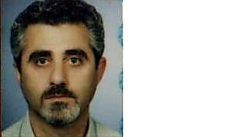
1. Surname: SIDERIDIS

2. First name: PAVLOS

3. Date of birth: 03 – 10 - 1962

4. Nationality: GREEK

5. Civil status: MARRIED

6. Education: LYCEUM

Institution: | PROFESSIONAL EDUCATION SCHOOL
Date: from (months/year) to (months/year) | 1980 - 1982
Degree(s) or Diploma(s): | ACCOUNTANCY ASSISTANT
Institution: | LYCEUM OF KILKIS
Date: from (months/year) to (months/year) | 1977 – 1980
Degree(s) or Diploma(s): | Post-compulsory Secondary Education

7. Language skills: (Mark 1 min. to 5 max. competence)

Language | Reading | Spoken | Written
ENGLISH | 1 | 1 | 1
GERMAN | 4 | 4 | 4

8. Membership of professional bodies:

9. Other skills: COMPUTER (MS WINDOWS, MS OFFICE, EXPLORER)

10. Present position: MUNICIPALITY OF PIKROLIMNI: ACCOUNTANCY OFFICE, FACILITATOR OF PIEEC

11. Years within the firm: 15

12.Key qualifications

13. Specific experience in European programs

Country | Date: from  (month/year) to (month/year) | Name and brief description of the project

14. Professional experience record:

Date: from - to
Location
Company
Position

15. Others: (e.g. publications)

